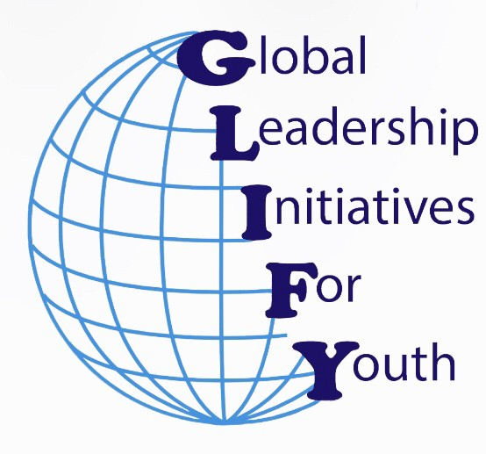Global Leadership Initiatives for Youth

[www.hsleadershipinitiative.org](http://www.hsleadershipinitiative.org/) [globalleadershipinfo@gmail.com](mailto:globalleadershipinfo@gmail.com)

Global Leadership Initiatives for Youth (GLIFY) is a 501(c)3 nonprofit organization made up of high school and middle school students in the East Bay of Northern California. We aim to inspire each other to make an impact on local and global communities. Thank you for your service and volunteer contributions!

**Student Name: School Name:**

**Email /Phone: Grade:**

**Activity/Project name:**

**Log of multiple events within the activity/project:**

|  |  |  |  |
| --- | --- | --- | --- |
| **Date** | **Description of Event** | **Number of Hours** | **Signature of Supervisor** |
|  |  |  |  |
|  |  |  |  |
|  |  |  |  |
|  |  |  |  |
|  |  |  |  |
|  |  |  |  |
|  |  |  |  |
|  |  |  |  |
|  |  |  |  |
|  |  |  |  |
|  |  |  |  |
|  |  |  |  |
|  |  |  |  |
| Total |  |  |  |

Name of Non-profit Organization: Authorizing official’s name:

Email: Phone: